Birthday girl Kirra already has the gift of compassion
- Michelle Ainsworth From: Herald Sun March 31, 2012 12:00AM

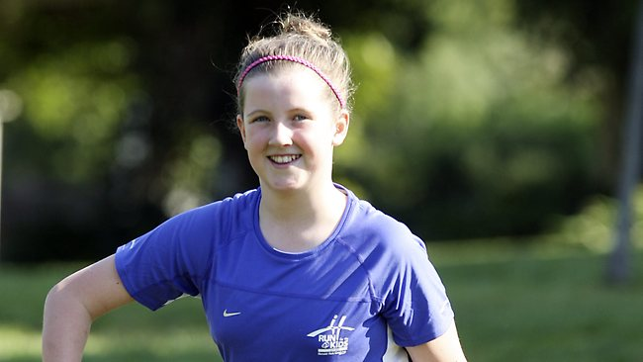
KIRRA PARKS IS LOOKING FORWARD TO RUN FOR THE KIDS TOMORROW. PICTURE: NORM OORLOFF HERALD SUN
CELEBRATING her 11th birthday this month, Kirra Parks wanted just one thing: to run in the Herald Sun/CityLink Run for the Kids tomorrow.
The charity-minded primary school student told her mum and dad she didn't want presents.
"I wanted to help raise money for the kids in the Royal Children's Hospital to help buy equipment so they can get better," Kirra said. "We bought the entrance fee and I wanted to buy the (Run for the Kids) top to raise more money."
Mum Sharon said it was not such an odd birthday present for Kirra.
"This isn't unusual coming from her because they do a lot of charity stuff at school. I wasn't surprised at all," Ms Parks said.
The family will join 33,000 participants in the seventh annual run tomorrow.
The 5.2km course starts at 8.40am and the 14.38km course at 9.15am.
Roads will be closed from midnight tonight. Visit runforthekids.com.au for full road closure information.

